STATE OF CALIFORNIA GRAY DAVIS, Governor
PUBLIC UTILITIES COMMISSION
505 VAN NESS AVENUE
SAN FRANCISCO, CA 94102-3298
June 15, 2001

TO: PARTIES OF RECORD IN INVESTIGATION 99-06-036

This proceeding was filed on June 15, 2001, and is assigned to Commissioner Loretta Lynch and Administrative Law Judge (ALJ) Jeffrey O’Donnell. This is the decision of the Presiding Officer, ALJ Jeffrey O’Donnell.

Any party to this adjudicatory proceeding may file and serve an Appeal of the Presiding Officer’s Decision within 30 days of the date of issuance (i.e., the date of mailing) of this decision. In addition, any Commissioner may request review of the Presiding Officer’s Decision by filing and serving a Request for Review within 30 days of the date of issuance.

Appeals and Requests for Review must set forth specifically the grounds on which the appellant or requestor believes the Presiding Officer’s Decision to be unlawful or erroneous. The purpose of an Appeal or Request for Review is to alert the Commission to a potential error, so that the error may be corrected expeditiously by the Commission. Vague assertions as to the record or the law, without citation, may be accorded little weight.

Appeals and Requests for Review must be served on all parties and accompanied by a certificate of service. Any party may file and serve a Response to an Appeal or Request for Review no later than 15 days after the date the Appeal or Request for Review was filed. In cases of multiple Appeals or Requests for Review, the Response may be to all such filings and may be filed 15 days after the last such Appeal or Request for Review was filed. Replies to Responses are not permitted. (See, generally, Rule 8.2 of the Commission’s Rules of Practice and Procedure.)

If no Appeal or Request for Review is filed within 30 days of the date of issuance of the Presiding Officer’s Decision, the decision shall become the decision of the Commission. In this event, the Commission will designate a decision number and advise the parties by letter that the Presiding Officer’s Decision has become the Commission’s decision.

/s/ LYNN T. CAREW
Lynn T. Carew, Chief
Administrative Law Judge

LTC:sid
Attachment
ALJ/JPO-POD/sid

PRESIDING OFFICER’S DECISION (Mailed 6/15/2001)

BEFORE THE PUBLIC UTILITIES COMMISSION OF THE STATE OF CALIFORNIA

Investigation into Commonwealth Energy Corporation’s Operations and Practices in Connection with Providing Service as an Electricity Service Provider under Registration No. 1092,  Respondent. | Investigation 99-06-036  (Filed June 24, 1999)

E. Gregory Barnes and Paul A. Szymanski,
Attorneys at Law, for San Diego Gas & Electric
Company, interested party.
Milbank, Tweed, Hadley & McCloy, by Kevin McSpadden
and Kenneth A. Ostrow, Attorneys at Law, for
Commonwealth Energy Corporation, respondent.
Carol A. Dumond, Attorney at Law, for the Consumer
Services Division.

O P I N I O N

Summary
In this investigation, the Commission sought to determine whether Commonwealth Energy Corporation (Commonwealth) violated Public Utilities Code Sections 394.5(a) and 394.25(b)(1). These code sections require that terms and conditions of service be clearly communicated to customers, and that utilities not make material misrepresentations to customers when soliciting the customers’ business.
In this opinion, we adopt a settlement between our Consumer Services Division (CSD) and Commonwealth. The settlement provides for, among other things, $219,500 in fines, approximately $649,000 in restitution to customers who received and paid supplemental bills, and reimbursement to the Commission of $37,000 in audit costs.

Procedural History
This proceeding was initiated based upon an initial investigative report prepared by CSD that alleged the violations noted above.
The assigned Commissioner issued a scoping memo and ruling on August 12, 1999, and designated Administrative Law Judge (ALJ) Jeffrey P. O’Donnell as the presiding officer.
Evidentiary hearings were held on June 5 and August 9, 2000.
On May 3, 2001, CSD filed a motion to adopt a settlement agreement (settlement) attached to the motion and signed by CSD and Commonwealth. The settlement is included as Attachment A to this opinion.
On May 10, 2001, Commonwealth filed a motion to adopt the settlement.
On May 14,2001, San Diego Gas and Electric Company (SDG&E) sent a letter to the ALJ stating that it has no objection to the settlement.
The proceeding was submitted on May 14, 2001.
By letter dated June 8, 2001 to the ALJ, Commonwealth made corrections to two Public Utilities Code references in the settlement. By letters dated June 12, 2001, CSD and SDG&E agreed to the corrections. We have made those corrections to the settlement included as Attachment A to this decision.

CSD’s Initial Allegations
CSD alleged that Commonwealth had a growing number of customers (more than 159 as of June 1, 1999) dissatisfied enough to write or call the Commission registering complaints and seeking assistance in resolving their issues. About 40 customers submitted funds for impound at the Commission pending resolution of their complaints.
Specifically, CSD alleged that Commonwealth violated Section 394.5(a), which requires that terms and conditions of service be clearly communicated to prospective customers, by failing to disclose to consumers, among other things, the terms and potential extent of any supplemental billing. CSD also alleged that Commonwealth violated Section 394.25(b)(1), which forbids electricity service providers from making material misrepresentations in the course of soliciting customers and entering into service agreements with them.
CSD represented that a large number of Commonwealth’s customers were sent supplemental bills for service provided many months before. CSD stated that these were apparently not initial service start-off or logistical problems between Commonwealth and utility distribution companies (UDCs), instances of UDCs failing to issue bills in a timely manner, or glitches in Commonwealth and the UDCs’ computer communications. CSD alleged that most of the complaining customers had expressed concern about Commonwealth’s billing practices. The customers claimed that Commonwealth had sent them supplemental bills as long as seven months after the initial billings, and in amounts ranging from just a few cents to over $2,000. CSD alleged that the terms and conditions of service that Commonwealth provided to its customers did not mention authorization for such extensive supplemental billing. Therefore, Commonwealth did not follow the terms it provided when soliciting business from consumers. CSD believed, from preliminary information received in its investigation from Commonwealth, that at least 19,000 customers were sent supplemental bills. CSD also believed that the supplemental bills may not have been calculated using the correct billing rate for the periods in question. The billing calculations were made by Commonwealth, with each UDC simply passing along the amounts to individual customers with the UDC’s monthly bills.
CSD also represented that a large number of the customers it interviewed complained that Commonwealth was not delivering the promised savings as compared to the electricity bills they would have received had they been served by their UDC. CSD said that it had copies of letters, sent by Commonwealth to potential customers, guaranteeing savings of as much as 15-25%.
CSD noted that almost all of the written complaints received by the Consumer Affairs Branch (CAB) complain either that efforts to reach someone at Commonwealth about these issues were unsuccessful, or that Commonwealth did not follow through in responding.
CSD raised an additional issue. On August 15, 1997, Commonwealth filed an application for registration as an electricity service provider. The Commission’s Energy Division granted the application on August 18, 1997. On June 18, 1998, Commonwealth filed an application to supplement its original application. The supplement was signed by Frederick M. Bloom, Commonwealth’s chief executive officer at the time.
The supplement, among other things, stated that no corporate officer had any civil, criminal, or regulatory sanctions against him or her in the last 10 years. CSD alleged that Bloom had regulatory action taken against him several times within the last 10 years. Therefore, CSD alleged that the supplement contained false information.

Commonwealth’s Response to CSD’s Initial Allegations
Commonwealth represented that, for a variety of reasons, many of its bills for electricity were understated during the last half of 1998. Often, this was due to the difficulty that Commonwealth was experiencing in calculating the Power Exchange credit of the UDCs, given the information that was made available by the UDCs. The credit was the base from which Commonwealth calculated discounts. In addition, there were lags in charges by the California Independent System Operator for ancillary services. As a result, customers often received inaccurately low bills. In some cases, customers were overbilled.
After informing the Commission’s Energy Division of the situation, Commonwealth sent a notice to customers advising them that they would receive supplemental bills to correct previous misbillings. In February 1999, supplemental bills were mailed. This triggered an unprecedented number of customer complaints that overwhelmed the four Commonwealth service representatives who were trained to handle customer inquiries. As a result, customers complained to CAB.
Commonwealth stated that since the supplemental billing event, complaints at Commonwealth have dropped to nearly zero. At the same time, the number of customers has grown from approximately 42,000 in February 1999 to over 60,000. Commonwealth’s ability to respond to customer concerns has grown as well. In February 1999, there were only 22 call center employees. The number of employees in Commonwealth’s call center has expanded to over 60 employees and is expected to increase to over 100. Six call center employees are specifically assigned to customer service, with other employees being trained so as to be able to augment the efforts of the six.

The Settlement
The settlement provides as follows:
- Commonwealth agrees to pay $20,000 for each of seven violations of Section 394(b)(8) for failing to report, in its registration application, sanctions imposed during the previous 10 years on its then-President, Chairman and Chief Executive Officer, Fredric M. Bloom (Bloom). The amount of the fine is $140,000.
- Commonwealth agrees that if Bloom returns in any capacity, or former President David Mensch returns as a director, officer or employee within Commonwealth or any of its subsidiaries, it will file an application with the Commission for re-registration under Section 394.1(a) disclosing the resumed relationship.
- Commonwealth agrees to pay $500 per violation of Section 394.5(a) for each of 159 supplemental bills sent to its customers and documented by CSD. The amount of the fine is $79,500.
- Commonwealth agrees to repay all customers who received supplemental bills the amount each paid less any amounts previously repaid. Any amounts that cannot be returned to the customers will be turned over to the State Controller for the escheat process. The total amount of the restitution is approximately $649,000.
- CSD will audit the restitution process.
- Commonwealth agrees to pay the Commission $37,000 in fees owed to the CSD’s independent auditor which assisted CSD in its audit of Commonwealth’s billing records.
- Commonwealth agrees to cooperate with CSD in any future audit of its billing records.
- Commonwealth agrees to cooperate with CSD, the Commission’s Energy Division and/or any state or federal regulatory or law enforcement investigation of Bloom’s activities while he served as an officer of Commonwealth.

CSD and Commonwealth’s Support of the Settlement
CSD states in its motion that the settlement deals with the issue of notice as a prerequisite for supplemental billing. Commonwealth admits that the 159 instances of supplemental billing documented by CSD were violations of Section 394.5(a). A fine of $500 for each of the 159 documented instances of supplemental billing is imposed. In light of Commonwealth’s agreement to provide restitution, CSD believes that the statutory $500 minimum fine for each of the 159 instances of supplemental billing is reasonable.
CSD represents that the settlement deals with the issue of alleged misrepresentation of energy savings. CSD found that many of the representations to the public of energy savings were vague enough to be meaningless. Some of the representations might have been accurate for some customers and not for others. CSD believes that the issue is moot because Commonwealth corrected its advertising early in its development. Further, CSD believes that it is not clear that its earlier advertising was misleading.
CSD believes that the settlement helps prevent future supplemental billings without prior notice. Given that Commonwealth admits that the 159 instances of supplemental billing documented by CSD were in violation of Section 394.5(a), it cannot claim in the future that supplemental billing without prior notice is lawful.
CSD believes that the settlement deals with the misrepresentations on Commonwealth’s application for registration. The settlement provides for the maximum statutory fines for the violations. Commonwealth has already filed a re-registration application to correct the flaws in its original registration. In addition, Bloom and Mensch, the management team under whom the early advertising took place, will not have any further significant involvement with Commonwealth without the Commission’s approval. Mensch was president of Commonwealth after Bloom. CSD believes that Mensch knew of Bloom’s prior sanctions, and condoned the failure to report the sanctions and the supplemental billing.
CSD points out that the settlement does not require the Commission to administer the restitution to affected customers, but does provide for an audit of the restitution process. In addition, any undelivered restitution will be sent to the State Controller as unclaimed property subject to escheat.
CSD found that Commonwealth’s customer service operations are now properly staffed and equipped.
CSD and Commonwealth state in their respective motions that a careful review of the settlement and the record in this proceeding supports a finding that the settlement is reasonable in light of the whole record, consistent with law, and in the public interest.

Review of the Settlement
Rule 51.1(e) of the Commission’s Rules of Practice and Procedure requires that any settlement must be:
- Reasonable in light of the entire record;
- Consistent with applicable law; and
- In the public interest.
The settlement is proposed by CSD and Commonwealth, who are the active parties in this proceeding. The other party, SDG&E, has no objection to the settlement. Therefore, the settlement is unopposed.
Commonwealth represents itself, and CSD represents all ratepayers. The parties are, therefore, reflective of the affected interests.
CSD, with the help of its independent auditors, has completed most of what it intended to do in its investigation and is satisfied that its investigation is sufficient to support the settlement. CSD and Commonwealth state that the settlement is supported by the exhibits and testimony in the record. In the settlement, Commonwealth admits to most of CSD’s allegations. As a result, we find that the record is sufficient for us to evaluate the settlement. We also find that the settlement is reasonable in light of the record developed in this proceeding. Specifically, the record shows that all contentions in the investigatory order have been examined and evaluated, with most of the contentions shown to have merit, and to require sanctions as proposed in the settlement.
The fines imposed in the settlement are within statutory requirements. The fines and restitution are appropriate, given the nature of Commonwealth’s violations and the need to provide redress to customers. In addition, the settlement is not in violation of any applicable law, or any Commission rule or order. Therefore, we find that the settlement is consistent with applicable law.
The settlement’s provision for repayment of all customers who received supplemental bills provides restitution to affected customers. The settlement also provides for payment by Commonwealth of some of the costs incurred by the Commission in this proceeding, and avoids the costs of further litigation. In addition, the settlement provides that Bloom and Mensch will not have any further significant involvement with Commonwealth without the Commission’s approval. Therefore, we find that the settlement is in the public interest.
For all the foregoing reasons, we will adopt the settlement.
Findings of Fact
- CSD and Commonwealth filed motions for adoption of the settlement on May 3 and 10, 2001.
- The settlement is unopposed.
- The parties are reflective of the affected interests.
- In the settlement, Commonwealth admits to most of CSD’s allegations.
- The record is sufficient for the Commission to evaluate the settlement.
- The settlement is consistent with the record developed in this proceeding.
- The fines imposed in the settlement are within statutory requirements.
- The settlement is not in violation of any law, or any Commission rule or order.
- The settlement provides restitution to affected customers.
- The settlement provides for payment by Commonwealth of some of the costs incurred by the Commission in this proceeding, and avoids the costs of further litigation.
- The settlement provides that Bloom and Mensch will not have any further significant involvement with Commonwealth without the Commission’s approval.
Conclusions of Law
- The settlement is reasonable in light of the entire record, consistent with applicable law, and in the public interest.
- The settlement should be adopted.
- In order that Commonwealth may issue refunds to customers as soon as possible, this order should be effective immediately.

ORDER

IT IS ORDERED that:
- The motions for adoption of the Settlement Agreement between the Commission’s Consumer Services Division and Commonwealth Energy Corporation filed on May 3 and 10, 2001, respectively, are granted.
- The Settlement Agree ment, included as Attachment A to this decision, is adopted.
- This proceeding is closed.
This order is effective today.
Dated , at San Francisco, California.

ATTACHMENT A
Page 1
SETTLEMENT AGREEMENT
This Settlement Agreement (Agreement) is entered into by and between Commonwealth Energy Corporation (Commonwealth) and the Consumer Services Division (CSD) of the California Public Utilities Commission (Commission).
WHEREAS, Commonwealth is a California corporation which has registered with Commission as an Electricity Service Provider under Public Utilities Code (Code) § 394, and has been assigned registration number 1092; and
WHEREAS, on June 24, 1999 the Commission issued an Order Instituting Investigation (OII) in docket I.99-06-036; and
WHEREAS, the alleged violations identified in the OII occurred during the period that Frederick M. Bloom served as Chairman and CEO of Commonwealth, ending with Bloom’s removal from Commonwealth on or before January 1, 2000 by Commonwealth's Board of Directors; and
WHEREAS, the current management of Commonwealth and CSD desire to resolve all issues related to the past operations and past practices of Commonwealth; and
WHEREAS, Commonwealth and CSD acknowledge that fully contested hearings in the OII would be time-consuming and expensive for all parties, and that the public interest will be served by an order of the Commission approving this Agreement;
NOW, THEREFORE, in consideration of the mutual agreements and covenants herein, Commonwealth and CSD through their authorized

ATTACHMENT A
Page 2

representatives who are the signatories hereto, hereby agree to the following provisions of this Agreement as a means of fully resolving all issues between them.
- Commonwealth agrees to pay the statutory fine of $20,000 per violation of Code § 394(b)(8), for its failure to report, in its registration application, sanctions that had been imposed on its then-President, Chairman and CEO, Fred Bloom, during the last ten (10) years, for seven (7) violations of various consumer protection statutes, for a total of $140,000. The violations triggering the unreported sanctions were committed personally by Bloom prior to his serving as CEO of Commonwealth. Current Commonwealth management has subsequently determined that Bloom was the person who decided that such violations need not be disclosed in Commonwealth’s application. Commonwealth admits these seven violations of Code § 394(b)(8) were committed by Mr. Bloom in his capacity as Chairman and CEO. (See Exh. 3.) Commonwealth agrees that, if Bloom returns in any capacity whatsoever, or if former Commonwealth President David Mensch returns as a director, officer, or employee, within Commonwealth or any of its subsidiaries at any time after the adoption of this Agreement, Commonwealth shall immediately file a formal application for re-registration under Code § 394.1(a), disclosing the resumed relationship with either or both of these former officers. Commonwealth further agrees that it will serve a copy of any such application on CSD, as well as filing it with the Commission, and that it will refer in such application to this docket number (I.99-06-036), and to this paragraph of this Agreement. Commonwealth understands and agrees that any such application may
ATTACHMENT A
Page 3
be protested by agency enforcement staff, and that the Commission has jurisdiction and discretion, regardless of whether or not staff files a protest, to grant or deny re-registration.
- Commonwealth admits that supplemental bills were sent to certain of its customers at Bloom’s direction, and that this act was a violation of Code § 394.5, and agrees to pay a fine of $500 for each of the 159 violations documented in the initial Declaration of CSD’s Special Agent Rich Chan, for a total of $79,500. The fines shall be paid within 15 days of the adoption of the settlement by the Commission, with a check payable to the Commission for deposit in the General Fund.
- Commonwealth agrees to repay, to all Commonwealth customers who received a supplemental bill which forms part of the basis of the allegations herein, the amount of such supplemental bill paid by such customers within 90 days of the date of a final order of the Commission approving this Agreement. Commonwealth has estimated that supplemental bills totaling $648,725.23 were mailed to customers; see Exhibit COM-4, p. 2. Such repayment will take the form of either a credit for those customers who paid the supplemental bill and continue as Commonwealth’s customers, or the form of a refund for those who paid the supplemental bill but are no longer Commonwealth’s customers. To the extent that Commonwealth has already refunded all or a portion of the supplemental billing amount to any customer, this Agreement obligates Commonwealth to pay only the difference between amounts already paid and the entire supplemental bill amount. The Commission’s consultant will audit the restitution process, and CSD will petition to re-open this docket if
ATTACHMENT A
Page 4
the audit finds irregularities. Monies represented by returned or undeliverable restitution checks, and by checks which remain uncashed by their stale dates, will be turned over promptly to the State Controller as unclaimed property for the escheat process.
- Commonwealth agrees to pay the Commission $37,000 in fees owed by the Commission as of April 16, 2001 to its independent auditor, UCM, which assisted CSD in connection with the audit of Commonwealth’s billing records in preparation for the hearings which were scheduled to take place on that date.
- Commonwealth agrees to cooperate fully and freely, should CSD choose, at any future time, to confirm the accuracy of Commonwealth’s billing process, through an independent verification of Commonwealth’s records. Any billing problems found in this follow-up audit may only be the subject of a separate enforcement proceeding.
- This written Agreement contains the entire understanding and agreement of Commonwealth and CSD, and supersedes all other written and oral exchanges, or arrangements or negotiations among them or their representatives with respect to the subject matter contained herein and fully resolved hereby; and neither this Agreement, nor any of the terms of this Agreement, may be altered, amended, waived, terminated, discharged or modified, except by a writing properly executed by Commonwealth and agency enforcement staff. CSD agrees that this Agreement is dispositive of all issues that it believes should be pursued in Order Instituting Investigation (I.) 99-06-036
ATTACHMENT A
Page 5

This Agreement resolves and settles all causes of action, claims, disputes, allegations, and demands between CSD and Commonwealth, including:
a. all allegations raised by CSD in its investigative report to the Commission dated June 7, 1999, Exhibits 1 through 3, including the allegations that Commonwealth violated Code § 394.5(a) and Code
§ 394.25(b)(1);
b. all allegations raised by CSD in its investigative report to the Commission dated September 21, 1999, Exhibit 4, including the allegation that Commonwealth violated Code § 394(b)(8);
- By stipulation, all prepared testimony distributed by the parties is accepted into the record as evidence without cross-examination, subject to adoption of this Agreement by the Commission without hearings. In the event that the Commission requires hearings, the parties reserve the right to cross-examine each other’s witnesses on the exhibits and prepared testimony distributed as of the date of such hearings, as well as on any other matter on which the Commission may require hearings in this docket.
- Commonwealth agrees to cooperate fully and freely with CSD, the Commission’s Energy Division, and/or any state or federal regulatory or law enforcement agency, in any investigation of the activities of Bloom, during the period he served as an officer of Commonwealth.
ATTACHMENT A
Page 6
- The parties acknowledge the party status of San Diego Gas & Electric Company (SDG&E). SDG&E has reviewed the Agreement, and has advised Commonwealth and CSD that it has no objection to the Commission’s adoption of the Agreement.
- The Commission has advised the Court of Appeals that the Court’s mediation is not needed in connection with docket No. G027959.
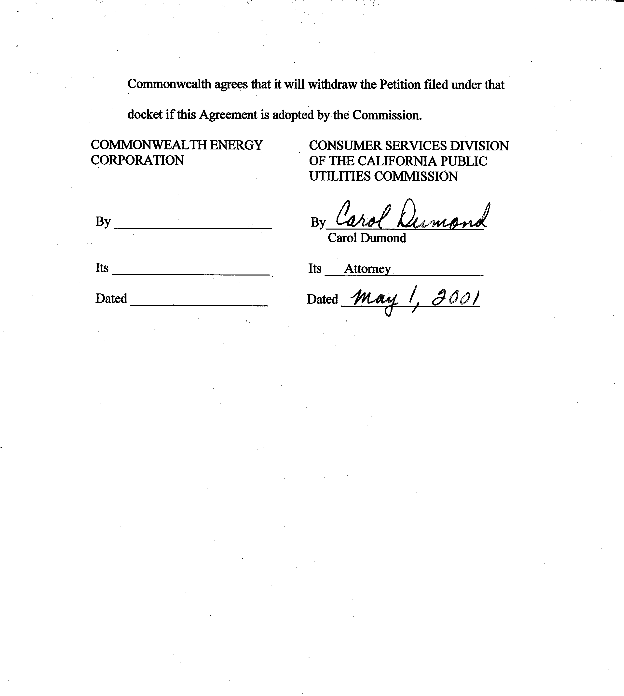
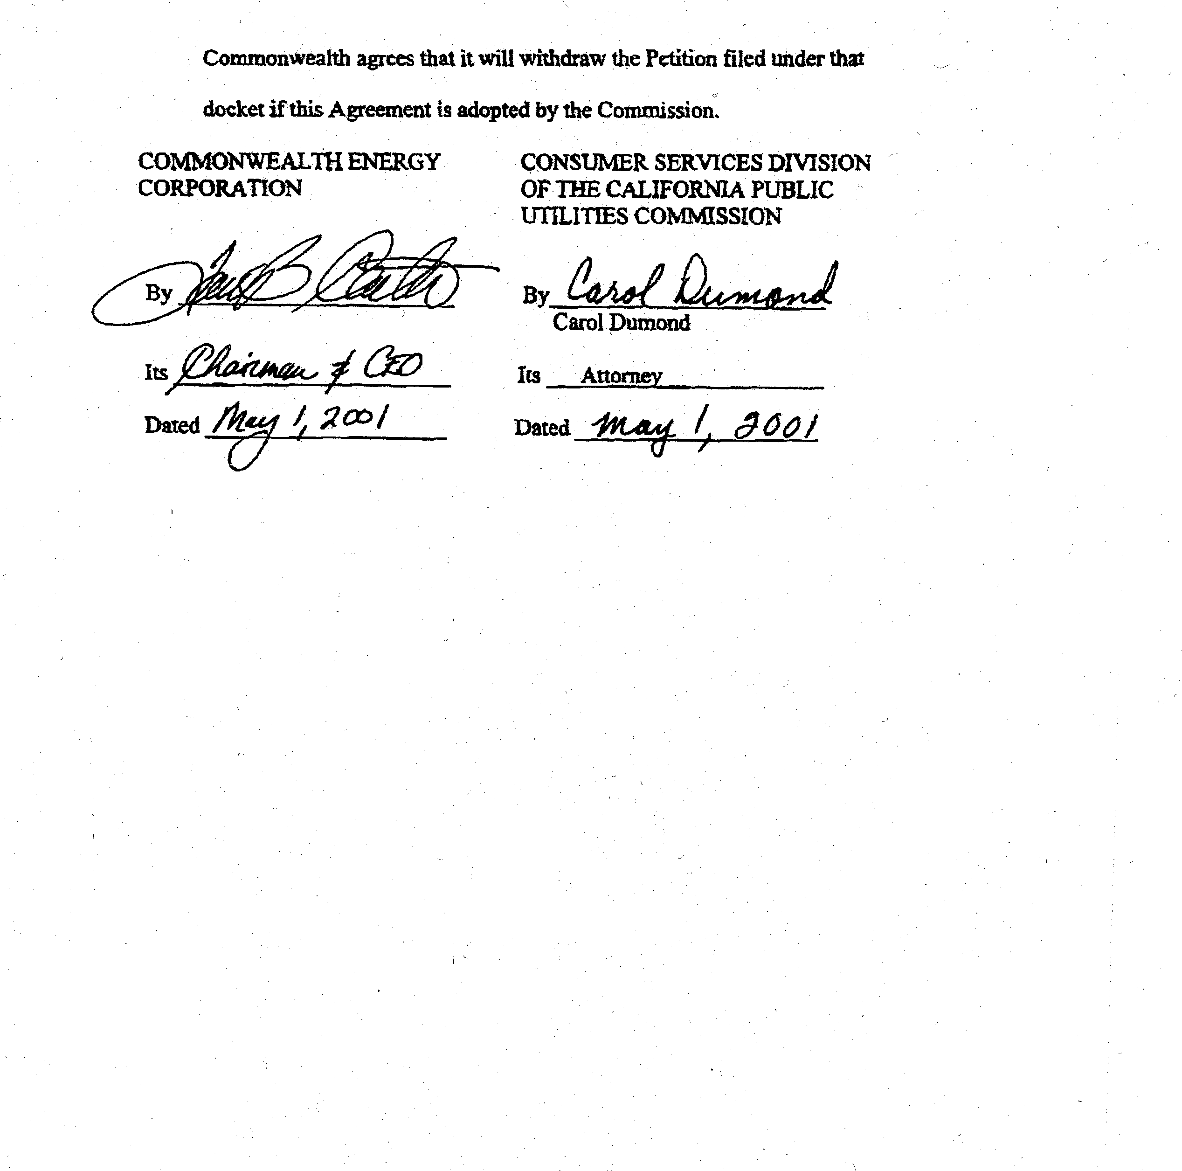

Unless otherwise noted, section references are to the Public Utilities Code.

